Cell Structure and Function Review
- Name the type of cell in the diagram below. ______________
Label each structure and complete the short description of the function of each structure.
Structure: ________________
Function: controls the activities of the cell and contains genetic material called ______
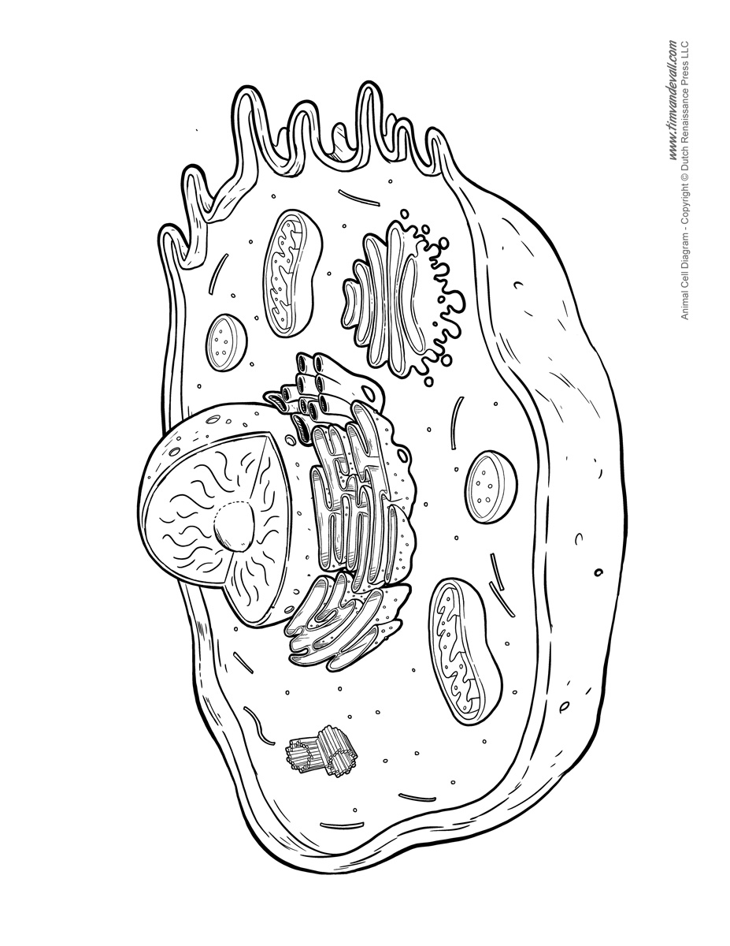
Structure: __________________
Function: organelle that holds __________, ___________, and ____________

Structure: _________________
Function: organelle that controls what enters and __________ the cell
Structure: _____________
Function: organelle that breaks down _______ and provides ENERGY for the cell
Structure: ________________
Function: jelly like substance that holds ___________

- What is the basic unit of all living things called? _____________

- Write the differences between prokaryote and eukaryote cells using the T-chart below. Give examples.
Prokaryote Eukaryote

- Do all cells have an organized nucleus? _________

- Do all cells have a cell membrane? _____________
- The cell theory states:
- All living things are made of ___________. This part of the cell theory was from the research of _____________ and ___________.
- __________ carry out the functions needed to support life.
- Cells come only from other living _________. This statement was added to the cell theory by _____________.

- Using a crude microscope, _________________________ first discovered “cells” as he viewed cork cells.

- Name the type of cell in the diagram below. _______________
Label each structure and write complete the description of the function of each
structure.
Structure: ______________
Function: organelle that breaks down _______ and provides ENERGY for the cell
Structure: __________________
Function: organelle that _________
Materials throughout the cell

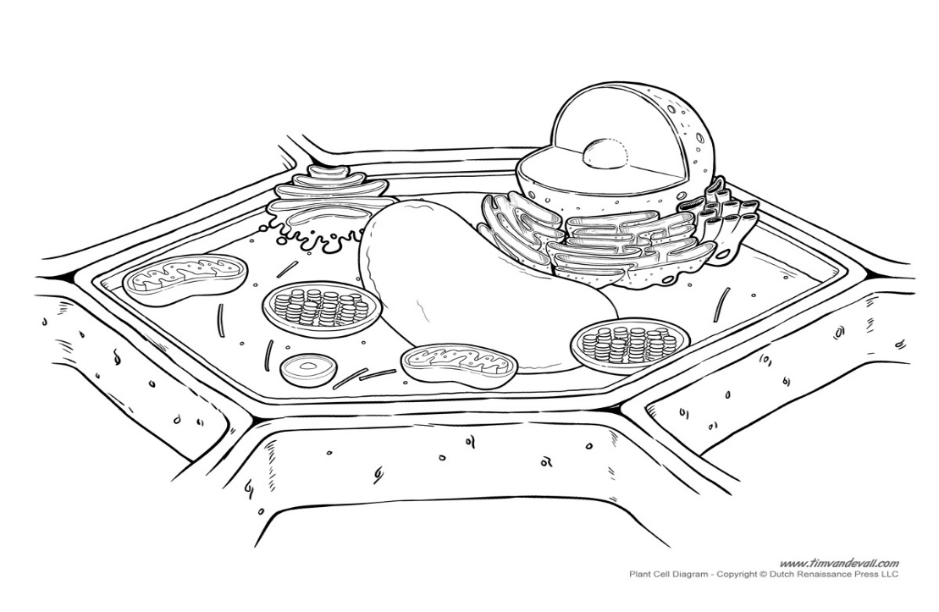
Structure: ___________________
Function: organelle that uses radiant __________ to make __________ in plant cells
Structure: _______________
Function: organelle that controls what enters and __________ the cell
Structure: ________________
Function: organelle that holds __________, ___________, and ____________

Structure: ________________
Function: rigid outer ________ of a _________ cell that helps provide rigidity to the cell
Structure: ________________
Function: controls the activities of the cell and contains genetic material called _________

- Name two organelles found only in the plant cell and algae cells; not in animal cells. ____________, _______________
- What organelle needs filling up if a plant is wilting? _______________

- The smaller parts of a cell that carry out specific functions are called __________. These parts enable (help) a cell to ________________________.

- Organisms, such as a paramecium, live in pond water and are made of only one cell. This type of organism is known as (unicellular, multicellular).

- Organisms, such as humans, are made of many cells that work together. This type of organism is known as (unicellular, multicellular).

- (Structure, Function) refers to the shape of a part of an organism and the material that the part is made of.
(Structure, Function) refers to the job that a part of an organism does.

- Living things are made of cells. List the levels in the correct order of organization from the simplest to most complex.
______________, ______________, ______________, ______________, ______________
- All organisms are made up of __________.

- A group of cells in an organism that have similar structure and function is called _________. Give an example.

- A group of tissues in an organism that perform a specific function is called a(n) _____________. Give an example.

- A group of organs that work together to carry out a particular task such as digestion is known as a(n) _____________ ___________. Give an example. ______________________________

- A group of organ systems working together form a(n) ______________. Give an example. ___________________________

