Lab Safety
Being safe and smart during a lab activity requires that you use common sense and
Look carefully at the picture. Find, label, and describe each of the following:
1. Find three BEHAVIORS (something someone is doing) that are unsafe:
A.
B.
C.
2. Find three BEHAVIORS (something someone is doing) that are safe:
A.
B.
C.
3. Find three SITUATIONS (the way things are set up) that are unsafe:
A.
B.
C.
4. Find three SITUATIONS (the way things are set up) that are safe.
A.
B.
C.
Write a list of simply-stated safety guidelines that you think are most important to follow during experiments that we will perform in our class this year.
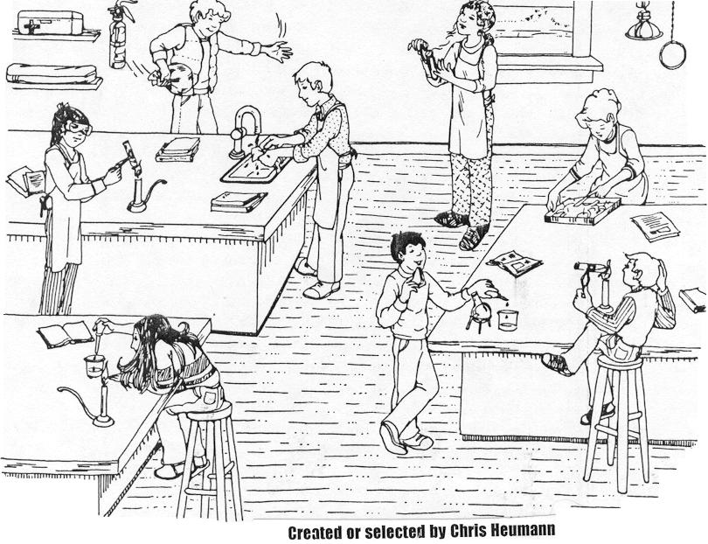
H
G
F
E
D
C
B
A

