Muscular and Nervous System Review

**Use the diagram for questions #1 and #2**

1. What two systems are working together?
2. How are these two systems working together?
3. Define cartilage.
4. Define tendon.
5. Define ligaments.
6. Does cartilage or tendon act as a shock absorber during movement?
7. Is cartilage spongy or rigid?
8. What part of the brain controls involuntary actions, such as breathing and digestion?
9. What part of the brain primarily controls movement?
10. What portion of the central nervous system controls all mental activities and voluntary actions?

(Cerebrum, Cerebellum or Brain Stem)

1. What human body systems might work together when a student steps on a thorn?
2. Which type of muscle is striated? (Smooth, Skeletal or Cardiac) Is this voluntary or involuntary muscle? _________________

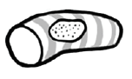

1. Muscles typically work in _________________.
2. Muscles only ________ not push.
3. This type of muscle is located in the walls of the hollow internal structures such as stomach, blood vessels, and air ways. (Smooth, Skeletal or Cardiac) Is this voluntary or involuntary muscle? _______________

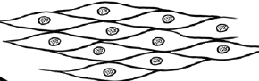

1. This type of muscle is only found in the diagram below:

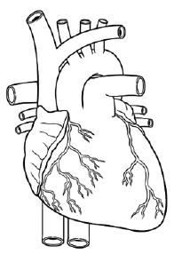 Is it voluntary or involuntary? _________________

1. Which body system is responsible for interacting with the environment?
2. Even though joints is defined as two or more bones joined together, typically, (#) ________ bones are joined together in a (movable/immovable) joint.

**Use the pictures for # 12 and #13.**

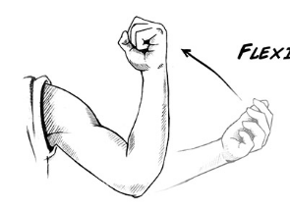 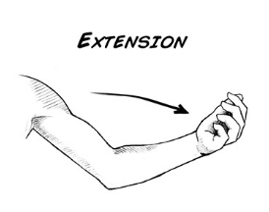

1. When a muscle contracts (flexion), it is ______________.(shortening or lengthening)
2. When a muscle extends (extension), it is _______________.(shortening or lengthening)
3. Define homeostasis.
4. Give an example of when your body is trying to maintain homeostasis. Explain.
5. **Complete the chart below with the correct term.**

**Term Description**

|  |  |
| --- | --- |
|  | Fibers that receive messages from other neurons |
|  | Part of the neuron that contains the nucleus and other organelles |
|  | Part of the neuron that receives nerve impulses and carries them to other cells |
|  | The gap between neurons where messages jump from one neuron to the next |
|  | Button-like endings of axons that make synaptic contact with other nerve cells |

1. Name the two main parts of the nervous system.
2. Which part of the nervous system is composed of the brain and spinal cord?
3. Which part of the nervous system is composed of the nerves that branch off the brain/spinal cord?
4. Draw 2 neurons and explain the parts of the neuron. Include the synapse.