Muscular and Nervous System Review Key

**Use the diagram for questions #1 and #2**

1. What two systems are working together? Skeletal and nervous systems
2. How are these two systems working together? The nervous system supplies the impulses to move the bones. The skeletal system protects the spinal cord.
3. Define cartilage. Smooth, slippery cushion between bones; provides strength to structures such as ears & nose without being rigid.
4. Define tendon. Bands of tissue, usually white and fibrous, serving to connect muscle to bone
5. Define ligaments. Bands of tissue, usually white and fibrous, serving to connect bone to bone
6. Does cartilage or tendons act as a shock absorber during movement? Cartilage
7. Is cartilage spongy or rigid? spongy
8. What part of the brain controls involuntary actions, such as breathing and digestion? Brain stem
9. What part of the brain primarily controls movement? Cerebrum
10. What portion of the central nervous system controls all mental activities and voluntary actions?

(Cerebrum, Cerebellum or Brain Stem)

1. What human body systems might work together when a student steps on a thorn? Nervous and muscular/skeletal
2. Which type of muscle is striated? (Smooth, Skeletal or Cardiac) Is this voluntary or involuntary muscle? voluntary

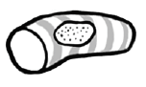 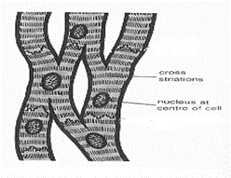 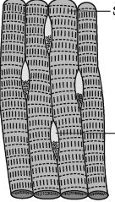

1. Muscles typically work in pairs.
2. Muscles only pull not push.
3. This type of muscle is located in the walls of the hollow internal structures such as stomach, blood vessels, and air ways. (Smooth, Skeletal or Cardiac) Is this voluntary or involuntary muscle? Involuntary

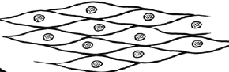

1. This type of muscle is only found in the diagram below: cardiac muscle

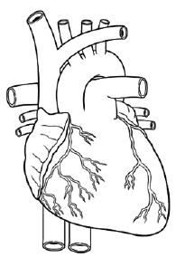 Is it voluntary or involuntary? Involuntary

1. Which body system is responsible for interacting with the environment? Nervous system
2. Even though joints is defined as two or more bones joined together, typically, (#) 2 (or more) bones are joined together in a (movable/immovable) joint.

**Use the pictures for # 12 and #13.**

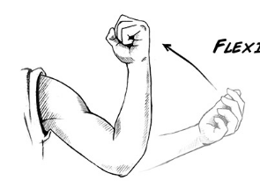 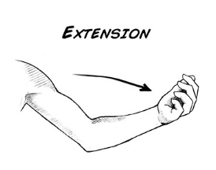

1. When a muscle contracts (flexion), it is shortening .(shortening or lengthening)
2. When a muscle extends (extension), it is lengthening.(shortening or lengthening)
3. Define homeostasis: To maintain a constant internal environment when outside conditions change allowing all systems to work properly.
4. Give an example of when your body is trying to maintain homeostasis. Explain. Shivering when the outside is too cold. Sweating when too hot.
5. **Complete the chart below with the correct term.**

**Term Description**

|  |  |
| --- | --- |
| Dendrites | Fibers that receive messages from other neurons |
| Cell body | Part of the neuron that contains the nucleus and other organelles |
| Axon | Part of the neuron that receives nerve impulses and carries them to other cells |
| Synapse | The gap between neurons where messages jump from one neuron to the next |
| Axon terminal | Button-like endings of axons that make synaptic contact with other nerve cells |

1. Name the two main parts of the nervous system. Central Nervous system; Peripheral Nervous system
2. Which part of the nervous system is composed of the brain and spinal cord? Central nervous system
3. Which part of the nervous system is composed of the nerves that branch off the brain/spinal cord? Peripheral nervous system
4. Draw 2 neurons and explain the parts of the neuron. Include the synapse.

