**Neuron**-microscopic nerve cells that make up the brain, spinal cord, and nerves

**Axon terminal**: button-like endings of axons that make synaptic contact with other nerve cells

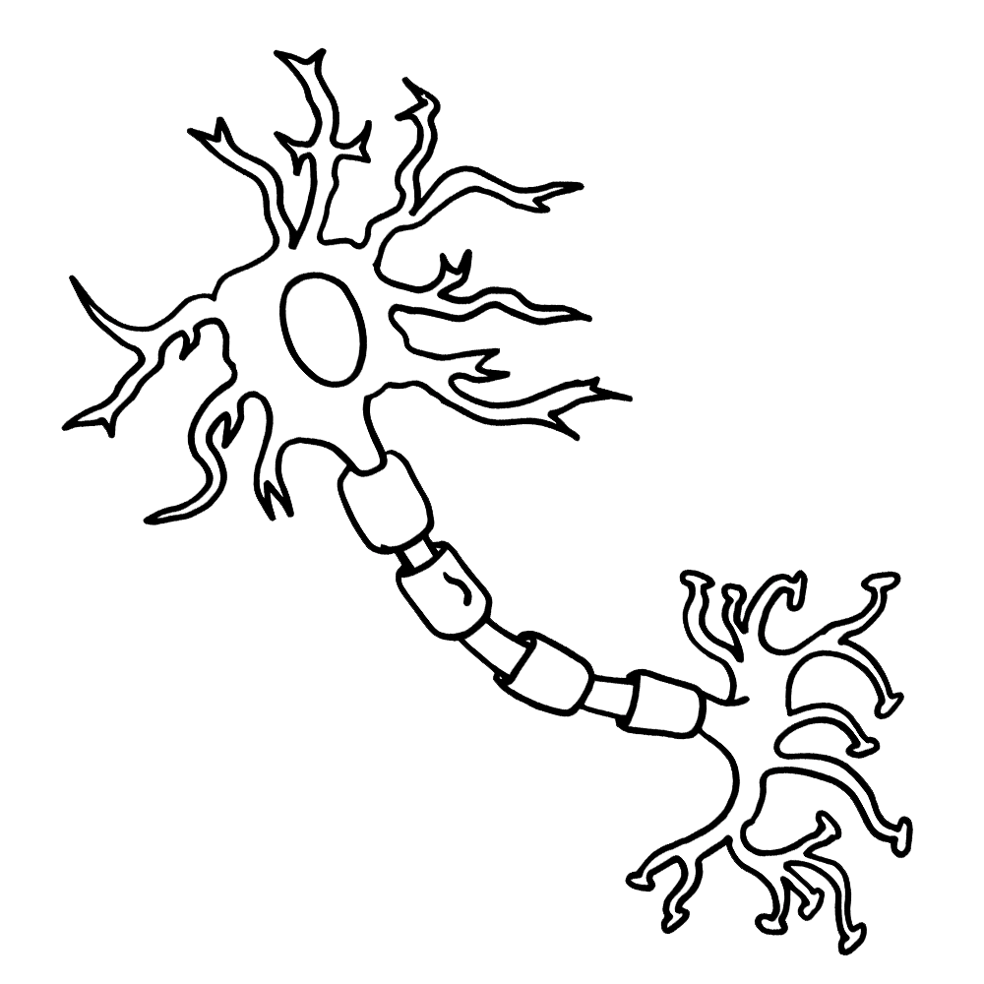

**Cell Body** with nucleus; gathers information from dendrites

**Dendrites**: fibers that receive messages from other neurons

**Synapse**: the gap between neurons where messages jump from one neuron to the next



**Axons**: fibers that send messages to other neurons