Quarter 2 Science Review

Look at the diagram below to answer the questions that follow.
- Which type of eukaryotic cell is pictured? _____________
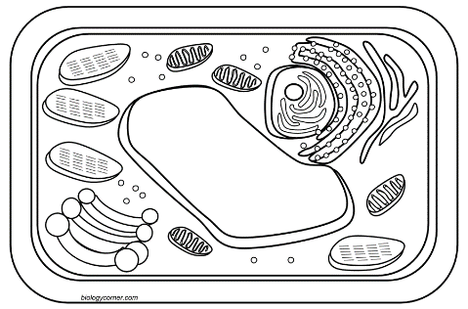

- Plant cells are composed of smaller parts called _____________.
- Put a red star on the organelle responsible for turgor pressure within the plant cell.
- Put a green on the organelle responsible for determining genetic traits within an organism such as eye color or blood type.
- Which organelle is responsible to be the place where chromosomes are located? _______________
- Where is the genetic material determining inherited traits located within the cell? _______________
- A trait such as hair color can be passed from generation to generation. However, the color may be masked (covered) and reappear in a later generation. These traits are considered to be (inherited, acquired). Circle one.
- If a fox meets up with a rabbit in a field, the trait of the rabbit running and hiding in a hole from the fox, would be an example of a (inherited, acquired) trait. Circle one.

- Look at the diagram and answer the question that follows.
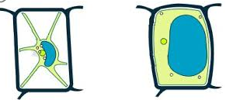

Label the correct cell as being turgid or flaccid. Use arrows to show the flow of water that the cell is experiencing.

Use the diagram to answer questions 10-11.
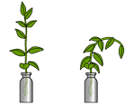
- Which of the following plants is experiencing turgor pressure? Circle one.

- The plant in the above diagram may be wilting due to not enough water inside the ______________. This would be a lack of ____________ _____________.

- A plant may use this organelle to control the amount of water lost through evaporation/transpiration during the hot part of the day.
- What is the name of this organelle on the underside of a plant leaf?___________
- Label each as open or closed.
- Put a red star next to the one that would represent how this organelle responds to a hot day in order to conserve water.
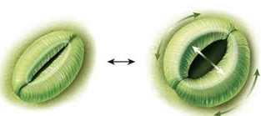
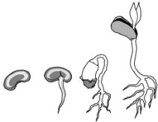
Use the diagram below to answer the questions that follow.

- The seed must exert a _______________ to push a shoot up through the soil.
- The roots are experiencing positive ______________ as the leaves are experiencing negative _______________.

Use the diagram below to answer the questions that follow.
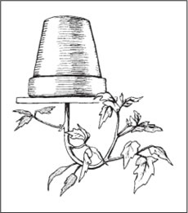
- In which direction would the leaves grow in this plant? Towards the ______________. The word meaning “to turn” is ______________.
- The leaves are experiencing positive _____________________.
- Which direction would the roots be growing?
- What force would cause the roots to turn in this direction?
Sexual Reproduction vs Asexual Reproduction
- The production of offspring from a single parent that is genetically identical to the parent is called (asexual, sexual) reproduction. Circle one.
- The production of offspring through the crossing or breeding of two parents and the offspring is/are not genetically identical to the parents is called (asexual, sexual) reproduction. This requires cell fertilization. Circle one.
- Which type of reproduction offers greater biodiversity? _________________________
- ___________________ reproduction offers greater genetic variation. Their traits are conserved from generation to generation.
- ___________________ reproduction offers less genetic variation.
- Greater genetic variation requires ______ reproduction (two parents), have better chances for survival, and an increased resistance to disease as compared to offspring from ______ reproduction.

- Identify the pictures below as asexual or sexual reproduction. **If asexual, identify the type.
Type of
Reproduction _____________ _____________ ____________ ________
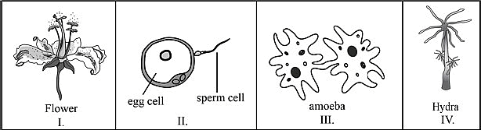

Type of
Asexual
Reproduction ___________ ____________ _____________ _________

- In all the examples of asexual reproduction, the offspring are genetically ____________ to the parent cell.

Genetics and Gregor Mendel
- An Austrian monk was a scientist that experimented using __________ plants to determine certain characteristics called ________________ that pass from one generation to the next.
- The term used to describe the passing of genetic instructions (characteristics) from one generation to the next would be ___________________.
- What is the study of heredity called? _________________
- The pea plant flower allowed Mendel to study the _____________ reproduction of plants since they have both male and female parts.
- Mendel let true breeding (purebred) plants self-___________________. Then, he ____________ a true breeding purple plant with a true breeding white plant. All of the offspring were _____________. (First generation)
- He determined that the trait that showed through most of the time was _________________.
- The trait that was masked or covered and would show in a later generation was _______________.
- Some traits are passed down from generation to generation. These are called _____________ traits.
- Some traits are learned. These are called __________________ traits.
- Determine if the following traits are inherited or acquired.
Blood type __________________
Eye color __________________
Color blindness __________________
Body weight __________________
- Mendel determined that in sexual reproduction, each parent donates one ___________ for each trait so the offspring will have __________ alleles for each trait.
- What is the basic genetic unit made of DNA called? _____________________
- What are the threadlike materials made of DNA located in the nucleus called? ______________ Hint: humans have 23 pairs
- Different forms of a gene that represents a trait is called an ______________.
- Having identical pairs of genes for a trait is ______________________.
- Having different pairs of genes for a trait is ______________________.
- (Genotype, Phenotype) refers to the physical appearance of a trait in an organism.
- (Genotype, Phenotype) refers to the genetic makeup of any trait in an organism.
- Gregor Mendel used a ____________ square to prove his ratio of offspring.

Complete the Punnett square below and answer the questions that follow.
Cross a homozygous dominant plant for the trait of being tall with a heterozygous tall plant.
T=tall t=short
46. What percentage of the offspring will be tall?
47. Are the offspring homozygous or heterozygous tall?
48. Are there any chances of short offspring?

Cross a heterozygous black rabbit with a heterozygous black rabbit.
B=Black b=white
49. What is the ratio of black to white in the offspring?
50. What percentage of the offspring was recessive?

51. Plants and animals must maintain an internal balance. The organism must maintain ________________.
52. Occasionally, plants and animals may experience an internal ______________ that requires a response in order to maintain that homeostasis.
53. What is a reaction to a stimulus? ____________________
54. What would a person’s body do to reach homeostasis if he was running a fever? _____________________________________________
55. What would a dog’s body do to reach homeostasis if he was cold? ________________________
56. If a child has a bacteria in his tummy, what response would he have to this stimulus? _____________________________
57. Plants also respond to stimuli with a response.
Plants responding to light experience _________________
Plants responding to water experience ________________
Plants responding to touch experience ________________
Plants responding to the Earth forces experience _______________
58. If two similar plants were watered a small amount each day, would you expect the plants to respond in a similar manner? ______________
What if one plant was watered with fresh water and the other with salt water? Would there be a difference? Use a separate sheet of paper to explain in detail. Draw a diagram.
Human Body Systems
59. Human body systems work _______________________ with each other.
60. What human body part is being protected by the vertebrae forming the spinal column? _____________
Which system is the vertebral column protecting? _________
61. The major function of the ________________ system is movement of the body.
62. The type of tissue that attaches bone to bone is _______________________.
63. The type of tissue that attaches muscle to bone is ______________________.
64. What human body systems might work interdependently together if I step on a thorn? ______________________________________________

